**Institutional Review Board Manual**

**Table of Contents**

Updated August 2024

Welcome to the Institutional Review Board (IRB) web page for the South Carolina Department of Mental Health (SCDMH).

The department recognizes the need for safeguarding the rights and welfare of research subjects and their private health information. In accordance with the US Department of Health and Human Services regulations, the SCDMH has an established Institutional Review Board which is charged with these responsibilities.  This web site is dedicated to providing the researcher with the tools and information necessary to protect these obligations and facilitate the approval process.

**About the IRB**

* Responsibilities of the IRB
* Board Members

**SCDMH Documents Governing Research**

* What Constitutes Human Subject Research
* Principles of Ethical Research

**Research that Requires Approval**

* Case Studies
* Exempt Projects
* Expedited Review Procedures
* Full Board Review Projects
* Continuing Review Requirement

**Approval Process**

* Required Protocol Information
* Required Informed Consent Information
* Steps, Timelines and Deadlines
* Required Training for Investigators
* Non-DMH Employees Requesting Research Permission

**HIPAA and Research**

* What is the Privacy Rule
* How it Affects Researcher
* Conditions for Use/Disclosure of PHI
* Obtaining Authorizations from Subjects
* De-Identified Data
* Criteria for and Requesting Waivers

**Special Population Requirements**

* Children
* Prisoners

**Resource Material**

* Common Rule
* Decision Charts
* Informed Consent Guidelines
* Informed Consent Resources

**Forms**

* Project Application for Research
* Facility/Center Director Letter of Support
* [Unaffiliated Investigator Agreement (Non-SCDMH Employee)  
  Privacy Practices Agreement (HIPAA)](#unaffiliated_investigator)
* Non-Employee Signature Page
* Continuing Review Form
* Request for a Waiver or an Alteration of Individual Authorization

**Institutional Review Board Manual**

**About the IRB****Responsibilities of the IRB for Human Research Subject Protections**

The South Carolina Department of Mental Health recognizes the need for safeguarding the rights and welfare of research subjects.  In accordance with Department of Health and Human Services regulations, the South Carolina Department of Mental Health has an established Institutional Review Board (IRB) which is charged with these responsibilities.

The SCDMH IRB is responsible for and the approving authority to:

1. **Protect** the rights and welfare of **human subjects** involved in research. These are protections for the person (the subject) and protections for the information the subject provides. Responsibilities:
   * Ensure that subjects are adequately informed of the nature of the study;
   * Ensure that subjects' participation is voluntary;
   * Ensure that the benefits of a study outweigh its risks;
   * Ensure that the risks and benefits of the study are evenly distributed among the possible subject population; and
   * Suspend human subject activity that violates regulations, policies, procedures, or an approved protocol, and report such violation and suspension to the Institutional Official.
2. **Protect** access to the subject’s **private health-related information and data**, e.g., diagnosis, treatment records, health status, billing records (HIPAA defined categories of information). Responsibilities:
   * Ensure that subjects are adequately informed on what private health-related data may be released to a researcher and that the release is voluntary
   * Ensure that all private health-related data that is released is adequately protected from further disclosure in any individually identifiable form
   * Ensure that there is an adequate plan to secure and protect the private health-related data during its use by the researcher
   * When it is not feasible to secure individual authorization for the release of private health-related information from a subject, ensure that all standards for de-identifying the data have been met or that requirements for a waiver of the authorization are met.

**About the IRB  
SCDMH Institutional Review** **Board Members**

|  |  |  |
| --- | --- | --- |
| **IRB MEMBERS** | **AFFILIATION** | **SPECIALTY AREA** |
| Monica J. McConnell, Ph.D. (Chair) | SCDMH Director of Child, Adolescent, and Family Services | Psychology/Community Mental Health |
| Jessica Davis, Psy.D. | SC Department of Disabilities and Special Needs | Intellectual Disabilities and Related Disabilities, Forensic Evaluations |
| Miroslav Cuturic, M.D. | SCDMH Division of Inpatient Services | Neurology |
| Alicia V. Hall, Ph.D. | SC **Department of Disabilities** and Special Needs (SCDDSN) | Psychology, Special Interest of Children |
| Leigh Ann Chmura | SCDMH Chief Information Officer | Information Management |
| Norma Jean Mobley, R.Ph. | Community | Pharmacy/Long Term Care |
| Kelly Gothard, Ph.D. | SCDMH Director of Forensic Services | Psychology, Forensics |
| Patricia Handley, DNP | SCDMH Systems Chief Nursing Officer | Nursing |
| Elizabeth Hutto, J.D. | SCDMH Office of General Counsel | Legal |
| **IRB Consultant** |  |  |
| Albert Patrick | SCDMH Privacy Officer | Privacy/Confidentiality |
| **Board Administrator,** Lynelle R. Reavis, Ph.D. Office: (803) 898-8619 email: [IRB@scdmh.org](mailto:IRB@scdmh.org) | | |
| **Address:** Lynelle Reavis Ph.D. Director of Quality Management and Compliance, IRB Administrator South Carolina Department of Mental Health 2414 Bull Street Suite 302 Columbia, SC 29201 | | |
| **Schedule of Meetings:  When:** Fourth Wednesday of each month, 11:30 AM | | |

**SCDMH FWA00025847 Expires** 09/29/2027**, IORG0000215 Expires** 09/21/2025

**SCDMH Documents Governing Human Subject Research**

The South Carolina Department of Mental Health recognizes the need for research. It also recognizes that research conducted at SCDMH must have clear current and/or potential value to the patients and staff as well as the person, institution or agency requesting to conduct human subject research

On July 1, 2008, the South Carolina Department of Mental Health (DMH) implemented a grant process under the Grants Administration Division to provide proper acquisition, administration, and monitoring of public and private funds for the agency.

The grant process requires the Grant Steering Committee to review all grant proposals to determine if the opportunity supports or advances the mission of the agency.

Pursuant to agency policy, only designated individuals (State Director or designee) are authorized to sign grant proposals, grant agreements, and award documents for the South Carolina Department of Mental Health.  The State Director has also authorized the Grants Administrator to sign sub-recipient agreements and federal grant contracts for the agency.  It is important to remember that only the above individuals can obligate the agency to state or federal grants/contracts.  All principal investigators (PI’s), project directors, grant employees, and any staff who process grant related paperwork must adhere strictly to the grant policy, particularly for federal grant or contract awards.

**What Constit****utes Research?**

**Research** means a systematic investigation, including research development, testing, and evaluation, designed to develop or contribute to common knowledge.  Some demonstration and service programs may include research activities which must be reviewed by the Institutional Review Board.

**Human subject** means a living individual about whom an investigator (whether professional or student) conducting research obtains:

1. Data through intervention or interaction with the individual.  
   **Intervention** includes both physical procedures by which data are gathered (e.g., venipuncture) and manipulations of the subject or the subject's environment that are performed for research purposes.  
   **Interaction** includes communication or interpersonal contact between investigator and subject.
2. Identifiable **private information.**  
   Individuals can reasonably expect that observations, notes, and/or recordings about their behavior will be kept private. If the individual can be identified by the researcher or anyone else (directly or indirectly through a coding system linking the research subject to the information), the information is deemed private.

**SCDMH Documents Governing Human Subject Research****Principles of Ethical Research**

The following principles are to be followed by the SCDMH Institutional Review Board (IRB) and all personnel in formulating and implementing research projects that involve human subjects.

**GENERAL PRINCIPLES**

1. Projects directly involving and/or individually identifying human subjects shall conform to the scientific, legal, and ethical principles which guide all research and shall emerge from a sound theoretical basis and follow accepted research design.
2. Ethical aspects of the study must be clearly stated in the project design.
3. Projects should be conducted only by professionally and scientifically qualified individuals.  When appropriate, medical liaison or supervision should be provided. The Institutional Review Board shall determine, prior to approving the project, that the Principal Investigator is an individual of sufficient competency and maturity or judgment and is on the staff or sponsored by the facility involved in the project.
4. Projects involving human subjects at risk shall not be implemented unless the anticipated risks to the subject are so outweighed by the importance of the knowledge to be gained as to warrant a decision to allow the subject to accept these risks.  The evaluation of such risks should include not only possible physical injury, but also psychological or social injury and alterations of personality.  
     
   "Subject at risk" means any individual who may be exposed to the possibility of injury, including physical, psychological, or social injury, as a consequence of participation as a subject in research.   
     
   If evidence of greater risks than that originally anticipated develops, the Principal Investigator will immediately discontinue the project and promptly report it to the IRB.
5. The Principal Investigator shall take all responsible steps and precautions to provide for the safety and welfare of subjects who consent to participate in projects.
6. The Principal Investigator shall take all reasonable steps to respect the privacy rights of any human subject.
7. Experimentation shall be planned so as to avoid unnecessary pain, embarrassment, suffering, or inconvenience to the subject, or their family or guardian.

**INFORMED CONSENT**

1. No project directly involving and/or individually identifying a human subject shall be undertaken without the subject's or the individual's legally authorized representative’s freely given written informed consent.   
   "Informed consent" means the knowing consent of an individual or the individual's legally authorized representative, so situated as to be able to exercise free power of choice without undue inducement or any element of force, fraud, deceit, duress, or other form of constraint or coercion.
2. The purpose of an Informed Consent is to fully disclose the purpose and risks of participation in the research and let the potential subject decide to participate or not on the basis of that disclosure.  This form will have the full information described in this section, as well as the date the consent form was signed and the name and contact information of the individual who supplied the subject with the information.
3. The information that is given to the subject or the representative shall be in language understandable to the subject or the representative.  No informed consent may include any exculpatory language through which the subject or the representative is made to waive or appear to waive any of the subject's legal rights or to release or appear to release the investigator, sponsor, the institution, or its agents from liability for negligence.
4. Subjects who are legally or functionally incompetent shall participate only when the consent has been given by the subject's legally authorized representative.  The research subject must be given a copy of the Informed Consent.
5. Denial of consent to participate in a project shall not be a cause for denying or altering the indicated services to that patient.
6. When children are being solicited as research subjects, the researcher shall consider adequate provisions for obtaining the child's Informed Consent.  The researcher shall, in determining whether children are capable of consenting or assenting, take into account the ages, maturity and the psychological state of the children involved.  The researcher shall be specific in identifying the ages of children for whom Informed Consent will be solicited, the ages for which parental (or guardian) permission is to be obtained and whether one or both parents must consent.  The latter shall be based upon the degree of risk involved in the research study (See section in Table of Contents: Special Population Requirements - Children).
7. The subject shall be allowed to withdraw consent and discontinue participation in a project at any time without affecting their status in the program.
8. The basic elements of information necessary to such consent include:
   1. A statement that the study involves research, an explanation of the purposes of the research and the expected duration of the subjects' participation, a description of the procedures to be followed, and identification of any procedures which are experimental.
   2. A description of any reasonably foreseeable risks or discomforts to the subject.
   3. A description of any benefits to the subject or to others which may reasonably be expected from the research.
   4. A disclosure of appropriate alternative procedures or courses of treatment, if any, that might be advantageous to the subject.
   5. A statement describing the extent, if any, to which confidentiality of records identifying the subject will be maintained and that notes the possibility that the Food and Drug Administration may inspect the records.
   6. An explanation of whom to contact for answers to pertinent questions about the research and research subject's rights, and whom to contact in the event of a research-related injury to the subject.
   7. A statement that participation is voluntary, that refusal to participate will involve no penalty or loss of benefits to which the subject is otherwise entitled, and that the subject may discontinue participation at any time without penalty or loss of benefits to which the subject is otherwise entitled.
   8. An explanation as to whether any compensation and an explanation as to whether any medical treatments are available if injury occurs and, if so, what they consist of, or where further information may be obtained.
   9. Consent forms for federally funded studies must include a concise and focused presentation of the key information at the beginning of the form in understandable language so that a reasonable lay person can evaluate whether to participate in a study
   10. Identifiable private information and identifiable biospecimens (e.g. Blood, urine, or tissue samples) Individuals must be informed whether their biospecimens may be used for commercial profit, the research may include whole genome sequencing, and clinically relevant research results, including individual results, will be disclosed, and if so, under what conditions.
9. When appropriate, one or more of the following elements of information shall also be provided to each subject:
   1. A statement that the particular treatment or procedure may involve risks to the subject (or to the embryo or fetus, if the subject is or may become pregnant) which are currently unforeseeable.
   2. Anticipated circumstances under which the subject's participation may be terminated by the investigator without regard to the subject's consent.
   3. Any additional costs to the subject that may result from participation in the research.
   4. The consequences of a subject's decision to withdraw from the research and procedures for orderly termination of participation by the subject.
   5. A statement that significant new findings developed during the course of the research which may relate to the subject's willingness to continue participation will be provided to the subject.
10. The requirement for obtaining an informed consent may be waived if either:
    1. The only record linking the subject and the research would be the consent document **and** the principal risk to the subject would be potential harm resulting from a breach of confidentiality; or
    2. The research presents no more than minimal risk of harm to subjects **and** involves no procedures for which written consent is normally required outside of the research context.

**Research that Requires Approval****Case Studies**

Although case studies usually do not meet the Common Rule definition of research (a systematic investigation, including research development, testing and evaluation designed to develop or contribute to generalizable knowledge) and as such do not require IRB review and approval all case studies must be reviewed by the applicable supervisor(s).

**Case Studies and Protected Health Information**

* Case studies that do not involve the receipt, disclosure or use of Protected Health Information, “PHI” (i.e., health information paired with identifiers such as name, SS#, DOB, address, etc.) do not require a signed “AUTHORIZATION TO DISCLOSE SCDMH PROTECTED HEALTH INFORMATION” or other privacy authorization to receive, disclose or use the non-PHI.
* All case studies that involve the receipt, disclosure or use of PHI must be reviewed by the local Privacy Officer (and if the use involves computer PHI, it must also be reviewed by the local Security Officer) for applicable Privacy Practices and other requirements (see Privacy Practices Directive 837-03 and applicable Security Policies.)

**Case Studies Requiring IRB Approval**  
Regardless of the number of study subjects, the activity is considered research and requires IRB approval if any of the following is present,

* + Investigational drug(s) or device(s) are involved (off-label use of an approved drug or device for the sake of an individual patient does not constitute research).
  + There is a clear intent before treating the patient to use systematically collected data that would not ordinarily be collected in the course of clinical practice in reporting and publishing the case study.
  + There is a plan to perform the treatment on some individuals but not on others.
  + There is intent to manipulate medications (even approved ones) to determine maximum effectiveness, or to test if they work consistently well.
  + Extra tests are conducted for the sake of reportability.
  + There is a protocol/study plan.
  + Records or data sheets are maintained separate from clinical records (particularly with identifiers).
  + The primary purpose is to answer a research question, not to provide care.
  + There is a possibility that the treatment might yield a case series if it is effective in others (e.g., testing a hypothesis).
  + There is intent to publish a report that is analytical not descriptive.

**Research that Requires Approval****Exempt Projects**

Research projects with human subjects may be exempt from Institutional Review Board (IRB) review only if they pose **minimal risk** to subjects.  **Minimal risk** means that the probability and magnitude of harm or discomfort anticipated in the research are not greater in and of themselves than those ordinarily encountered in daily life or during the performance of routine physical or psychological examinations or tests.

The following three categories of human subject research are exempt from IRB review:

1. Research involving the use of educational tests (cognitive, diagnostic, aptitude, achievement), survey procedures, interview procedures or observation of public behavior, unless:
   * Information obtained is recorded in such a manner that human subjects can be identified, **directly or through identifiers linked to the subjects; and**
   * Any disclosure of the human subjects' responses outside the research could reasonably place the subjects at risk of criminal or civil liability or be damaging to the subjects' financial standing, employability, or reputation.  
     ***Note:  The exemption for research involving survey or interview procedures or observation of public behavior does not apply to research with children.***
2. Research involving the collection or study of **existing** data, documents, records, pathological specimens, or diagnostic specimens, if:
   * These sources are publicly available; or
   * The information is recorded by the investigator in such a manner that subjects cannot be identified, directly or through identifiers linked to the subjects.  
     ***Note: The exemptions listed in items 1 and 2 above do not apply to research involving prisoners, fetuses, pregnant women, or human in vitro fertilization.***
   * The concept of “identifiers” referred to in items 1 and 2 above is often confusing to researchers.  Assigning codes to a subject and keeping the code in a secure place does not constitute de-identified data that exempts a project from IRB review.  When it is possible to identify a subject, directly or indirectly through identifiers linked to the subject, the study must be reviewed by the IRB.
3. Program Evaluation: The SCDMH IRB will exempt from IRB review data collection activities that are:
   * **Minimal risk: and**
   * For the sole purpose of evaluating the effectiveness of a service delivery program.    
     Program evaluation differs from research in a number of ways.  For example, program evaluation is not intended to add to a body of common knowledge; it may be an evaluation component of a service grant whose effectiveness is already documented; it has no control group; and/or it may be a quality improvement activity reviewing data collected as a routine part of the treatment or assessment.  If there is doubt about whether data collection is program evaluation or research, it should be submitted to the IRB.

***Note: Categories 1 and 2 are a condensation of §46.101, b, 1-6 of the Code of Federal Regulations, Title 45, Part 46. The full text of federal regulations for exempt projects may be found at:***

[45 CFR 46 | HHS.gov](https://www.hhs.gov/ohrp/regulations-and-policy/regulations/45-cfr-46/index.html) [Exemptions (2018 Requirements) | HHS.gov](https://www.hhs.gov/ohrp/regulations-and-policy/regulations/45-cfr-46/common-rule-subpart-a-46104/index.html)

**Research That Requires Approval****Expedited Review Procedures**

**Certain minimal risk projects, not eligible for exempt status, may be approved without full Institutional Review Board (IRB) review.  Research activities may be reviewed through the expedited review procedure that:**

1. **Present no more than minimal risk to human subjects; and**
2. **Involve only procedures listed in one or more of the following categories.**
   * **Clinical studies of certain drugs and medical devices;**
   * **Collection of small amounts of blood samples**
   * **Prospective collection of certain biological specimens, e.g., hair/nail clippings, sputum, mucosal and skin cells, by noninvasive means;**
   * **Collection of data through noninvasive procedures routinely employed in clinical practice, e.g., weighing or testing sensual acuity, EEG, EKG, ultrasound, or moderate exercise;**
   * **Research involving existing materials (data, documents, records, or specimens) collected solely for non-research purposes (such as medical treatment, diagnosis, or treatment planning);**
   * **Collection of data from voice, video, digital, or image recordings.**
   * **Research on individual or group characteristics or behavior (including, but not limited to, research on perception, cognition, motivation, identity, language, communication, cultural beliefs or practices, and social behavior) or research employing survey, interview, oral history, focus group, program evaluation, human factors evaluation, or quality assurance methodologies.**
   * **Continuing review of certain research previously approved by the IRB.**

**These categories apply regardless of the age of subjects.  For a review of the complete text, go to**

<https://www.govinfo.gov/content/pkg/CFR-2016-title45-vol1/pdf/CFR-2016-title45-vol1-part46.pdf>

**The activities (above) should not be deemed to be of minimal risk simply because they are included on this list. Inclusion on this list merely means that the activity is eligible for review through the expedited review procedure when the specific circumstances of the proposed research involve no more than minimal risk to human subjects.**

**The expedited review procedure may not be used if:**

1. **Identification of the subjects and/or their responses would reasonably place them at risk of criminal or civil liability or be damaging to the subjects’ financial standing, employability, insurability, reputation, or be stigmatizing, unless reasonable and appropriate protections will be implemented so that risks related to invasion of privacy and breach of confidentiality are no greater than minimal; or**
2. **The research deals with sensitive aspects of the subject’s behavior (e.g., illegal conduct, drug/alcohol abuse, sexual abuse, sexual preference, domestic violence) or studies involving deception.**

**Research that Requires Approval****Full Board Review Projects**

All research projects not meeting the criteria for Exempt or Expedited Review will be reviewed for approval by the full Institutional Review Board (IRB).  Prospective researchers are always welcome to attend.  When the IRB is able to discuss concerns and get clarifications from the researcher, delays in approval are frequently avoided.  Please contact the IRB Administrator via email: [IRB@scdmh.org](mailto:IRB@scdmh.org) or call 803-898-8619 to arrange attendance.

**Research that Requires Approval  
Co****ntinuing Review Requirement**

All research approved by the SCDMH Institutional Review Board is subject to Continuing Review, and no project may continue beyond one (1) year without re-approval. The time limit for submission of the Continuing Review Form is established during the initial review of the project.

**Approval Process  
Re****quired Protocol Information**

The Institutional Review Board (IRB) requires specific information to ensure the protection of research subjects and has developed a Project Application Form to capture this information.  Researchers are requested to complete and submit this Project Application Form along with a full copy of any research protocol that exists.

The minimal requested information includes:

1. A description of, and scientific rationale for, the proposed research activity; and
2. A discussion of the human subject protection issues which address, at a minimum:
   * Risks to subjects;
   * All experimental procedures;
   * Anticipated benefits to subjects, if any;
   * Anticipated number of subjects;
   * Subject selection, recruitment procedures, and subject inclusion/exclusion criteria:
   * Informed consent document and process to be used; and
   * Appropriate additional safeguards if potentially vulnerable subjects are to be enrolled, i.e., the elderly, prisoners, children, cognitively impaired people, or people who are economically or educationally disadvantaged.

The information should be in sufficient detail to allow the IRB to address the following areas:

* Proposed research design is scientifically sound & will not unnecessarily expose subjects to risk.
* Risks to subjects are reasonable in relation to anticipated benefits, if any, to subjects, and the importance of knowledge that may reasonably be expected to result.
* Risks to subjects are minimized.
* Subject selection is equitable.
* Informed consent is obtained from research subjects or their legally authorized representative(s).
* Additional safeguards required for subjects likely to be vulnerable to coercion or undue influence.
* Subject privacy & confidentiality are maximized.

**Approval Process  
Requir****ed Informed Consent Information**

Perhaps most central in Institutional Review Board (IRB) deliberations is the informed consent, for it is this document which explains to a potential research subject exactly what is being asked of him/her and the inherent risks/benefits of participation in the research.

No investigator may involve a human being as a subject in research unless the investigator has obtained the legally effective informed consent of the subject or the subject's legally authorized representative.

The IRB may waive the requirement to obtain informed consent provided the IRB finds and documents that:

1. The research involves no more than minimal risk to the subjects;
2. The waiver or alteration will not adversely affect the rights and welfare of the subjects;
3. The research could not practicably be carried out without the waiver or alteration; and
4. Whenever appropriate, the subjects will be provided with additional pertinent information after participation.

An investigator shall seek an informed consent only under circumstances that provide the prospective subject or the representative sufficient opportunity to consider whether or not to participate and under circumstances that minimize the possibility of coercion or undue influence.

The information that is given to the subject or the representative shall be in language understandable to the subject or the representative.  Investigators are encouraged to write informed consents at the 8th grade reading level.

No informed consent may include any exculpatory language through which the subject or the representative is made to waive or appear to waive any of the subject's legal rights, or releases or appears to release the investigator, sponsor, the institution, or its agents from liability for negligence.

The eight elements that are required for all informed consent forms include:

1. A statement that the study involves research, an explanation of the purposes of the research and the expected duration of the subjects' participation, a description of the procedures to be followed, and identification of any procedures which are experimental.
2. A description of any reasonably foreseeable risks or discomforts to the subject.
3. A description of any benefits to the subject or to others which may reasonably be expected from the research.
4. A disclosure of appropriate alternative procedures or courses of treatment, if any, that might be advantageous to the subject.
5. A statement describing the extent, if any, to which confidentiality of records identifying the subject will be maintained and that notes the possibility that the Food and Drug Administration may inspect the records.
6. An explanation of whom to contact for answers to pertinent questions about the research and research subject's rights, and whom to contact in the event of research-related injury.
7. A statement that participation is voluntary, that refusal to participate will involve no penalty or loss of benefits to which the subject is otherwise entitled, and that the subject may discontinue participation at any time without penalty or loss of benefits to which the subject is otherwise entitled.
8. For research involving more than minimal risk, an explanation as to whether any compensation and/or any medical treatments are available if injury occurs and, if so, what they consist of, or where further information may be obtained.

In addition, there are five additional elements that should be considered for inclusion depending on the nature of the research project.  They include:

1. A statement that the treatment/procedure may involve risks to the subject (or to embryo/ fetus, if the subject is or may become pregnant) which are currently unforeseeable.
2. Anticipated circumstances under which the subject's participation may be terminated by the investigator without regard to the subject's consent.
3. Any additional costs to the subject that may result from participation in the research.
4. The consequences of a subject's decision to withdraw from the research and procedures for orderly termination of participation by the subject.
5. A statement that significant new findings developed during the course of the research which may relate to the subject's willingness to continue participation will be provided to the subject.

**Approval Process****Steps, Timelines & Deadlines to Getting a Research Project Approved**

Proposals must be approved by all bodies governing the researcher that are external to DMH (i.e., university IRB, dissertation committee, etc.) prior their submission to the DMH Institutional Review Board (IRB).

The following steps, which are also presented graphically below, outline the procedure for approving research proposals in the South Carolina Department of Mental Health.

1. Submit the proposal to the appropriate DMH facility for site approval (Community Mental Health Center Director or In-patient Facility Director). The Center or Facility Director should then submit the Estimated Research Costs Form and a letter of support to their respective Division Director using the Facility/Center Director Letter of Support. The Division Director indicates on the same form his/her approval/disapproval of the project. If the Division Director approves, proceed to step #2 below. IRB approval does not ensure that any particular DMH facility will allow a research project to be conducted at their site.

Submit via email the SCDMH “Project Application for Research Involving Human Subjects,” Facility/Center Director Letter of Support and the Estimated Research Costs Form to the IRB Administrator email box [IRB@scdmh.org](mailto:IRB@scdmh.org) or mail to, IRB Administrator South Carolina Department of Mental Health, 2414 Bull Street Suite 302, Columbia, SC 29201.  
**These two documents must be submitted by the first Wednesday of the month to be eligible to be reviewed during that month's IRB meeting.** Non-SCDMH employees must sign and submit the Unaffiliated Investigator Agreement and Privacy Practices Agreement.

1. If the research proposal is approved by the Deputy Director or Acting Director it will be reviewed by the IRB Chair to determine its status (as either Exempt, Expedited, Full Board Review).
2. If the project meets the criteria for Exemption from IRB review, you will receive written notification within about four days from the IRB Administrator or IRB Chair.
3. If the proposal is eligible for Expedited Review, it will be reviewed within about four days and the researcher notified.  If it is not eligible for Expedited Review, or if concerns are raised by the reviewers, full IRB review is required.
4. The SCDMH IRB meets at 11:30 am on the fourth Wednesday of each month. The researcher is encouraged to attend this meeting. **Proposals to be reviewed by the SCDMH IRB must be submitted to IRB Administrator by the first Wednesday of each month in order to be reviewed by IRB that same month. Submissions received after the first Wednesday of a given month potentially will be reviewed by the IRB the following month.**
5. Following review, the DMH IRB will exercise one of three options: full approval of proposal; disapproval of proposal; or approval pending receipt of modifications to the proposal.  If modifications are required, they are explicitly communicated to the researcher who, upon fulfilling the requirements, does not usually have to resubmit the proposal for full IRB review.  Upon receipt of the modified proposal, IRB approval is given.

Researchers should be aware that any modifications to research proposals which may be required by DMH could necessitate re-approval by the researcher's governing body and/or any other IRB that has authority over the research.

***Note: Any grant funded research project must be coordinated through the DMH Grants Coordinator, as specified in the DMH Grant’s Directive.***

**Approval Process  
Req****uired Training for Investigators**

All investigators and key personnel submitting NIH applications are required by NIH to complete training in human subject protection and submit proof of training completion prior to the award of funds.  “Key personnel” include all individuals responsible for the design and conduct of the study.

This training is available on-line from a variety of sites, including:

* <https://www.hhs.gov/ohrp/education-and-outreach/online-education/human-research-protection-training/index.html> (Free of charge—Lessons 1 and 2 required for researchers)
* <http://phrp.nihtraining.com/users/login.php>
* <https://www.citiprogram.org/> (Organizational membership required)  
  or through any other acceptable source.  Contact the SCDMH IRB Administrator if assistance is required.

Certificates of completion should be submitted to the IRB Administrator. Upon receipt, the IRB Administrator will furnish the researcher with the required acknowledgment letter.

Contact the SCDMH IRB Administrator or Chair if assistance is required.

Send Training Completion Certificates via email to: [IRB@scdmh.org](mailto:IRB@scdmh.org)  
IRB Administrator or Chair South Carolina Department of Mental Health   
2414 Bull Street Suite 302  
Columbia, SC 29201

**Non-SCDMH Employees Requesting Research Permission**

All non-SCDMH employees requesting permission for subject contact and/or access to individually identifiable Protected Health Information (PHI) are required to read the Unaffiliated Investigator Agreement and the Privacy Practices Agreement and submit the Agreement Signature Page to the IRB Administrator as part of their Project Application

**HIPAA and Research  
W****hat is the Privacy Rule?**

The HIPAA Privacy Rule is a set of regulations that are separate and distinct from the Protection of Research Subjects regulations.  It pertains to the private health information of individuals, not the subject’s participation in the research project. The “Privacy Rule” – a Federal regulation under the Health Insurance Portability and Accountability Act (HIPAA) of 1996 – protects certain health information of individuals, living and deceased.

***Note: The Health Insurance Portability and Accountability Act (HIPAA) sections are reproduced from*** <http://privacyruleandresearch.nih.gov/pr_08.asp>***.***

**How HI****PAA Affects a Researcher**

The Privacy Rule of HIPAA (Health Insurance Portability and Accountability Act) regulates the way DMH (a covered entity) may use or disclose individually identifiable health information known as *protected health information (PHI)*. **In general, the Privacy Rule requires an individual to provide his/her signed permission, known as an Authorization, before a covered entity can use or disclose the individual's PHI for research purposes.**

HIPAA Authorizations may be included as content in an Informed Consent, or they may be a separate document.  In either case, the “Core Elements” that must be included in an Authorization may be found at Obtaining Authorizations from Subjects.

Under certain circumstances the Privacy Rule permits a covered entity to use or disclose PHI for research without an individual's Authorization. The documentation required for a waiver of the Authorization may be found at Criteria for Requesting Waivers.

For additional information on HIPAA and special requirements for researchers, see:   
<http://privacyruleandresearch.nih.gov/pr_02.asp>

**Condition****s for Use/Disclosure of PHI**

Protected Health Information (PHI) may be used and disclosed in research under three conditions:  
1.   the individual signs a written “authorization” giving permission;  
2.   the information or data is de-identified; or  
3.   PHI may be used and disclosed for research without an Authorization in limited circumstances.  This may be accomplished through:

* + Waiver
  + Data collection preparatory to research (See web site below for description).

For other conditions under this heading, see <http://privacyruleandresearch.nih.gov/pr_08.asp#8c>

**HIPAA and Research  
Obtaining A****uthorization from Subjects**

The first condition under which Protected Health Information (PHI) may be used and disclosed in research is by obtaining the subject's written permission.

The Written Authorization: A valid Privacy Rule Authorization is an individual's signed permission that allows a covered entity (SCDMH) to use or disclose the individual's PHI for the purposes stated in the Authorization and to the recipient or recipients as stated in the Authorization.

The Privacy Rule requires that an Authorization pertain only to a specific research study, not to nonspecific research or to future, unspecified projects. The Privacy Rule considers the creation and maintenance of a research repository or database as a specific research activity, but the subsequent use or disclosure by a covered entity of information from the database for a specific research study will require separate Authorization unless a waiver is granted. If an Authorization for research is obtained, the actual uses and disclosures made must be consistent with what is stated in the Authorization. In SCDMH, Authorizations are usually managed in the individual patient’s Community Mental Health Center or inpatient facility.

An Authorization can be combined with an informed consent document. Whether combined with an informed consent or separate, an Authorization must contain the specific core elements and required statements stipulated in the Rule.  These elements may be reviewed at: <http://privacyruleandresearch.nih.gov/authorization.asp>

**Authorization Core Elements**

* A description of the PHI to be used or disclosed, identifying the information in a specific and meaningful manner.
* The names or other specific identification of the person or persons (or class of persons) authorized to make the requested use or disclosure.
* The names or other specific identification of the person or persons (or class of persons) to whom the covered entity may make the requested use or disclosure.
* A description of each purpose of the requested use or disclosure.
* Authorization expiration date or expiration event that relates to the individual or to the purpose of the use or disclosure.  An Authorization for research uses and disclosures need not have a fixed expiration date or state a specific expiration event.  "End of the research study" or "none" is permissible for research, including for the creation and maintenance of a research database or repository.
* Signature of the individual and date. If the individual's legally authorized representative signs the Authorization, a description of the representative's authority to act for the individual must also be provided.

**Authorization Required Statements**

* A statement of the individual's right to revoke his/her Authorization and how to do so, and, if applicable, the exceptions to the right to revoke his/her Authorization or reference to the corresponding section of the covered entity's notice of privacy practices.
* Whether treatment, payment, enrollment, or eligibility of benefits can be conditioned on Authorization, including research-related treatment and consequences of refusing to sign the Authorization, if applicable.
* A statement of the potential risk that PHI will be re-disclosed by the recipient. This may be a general statement that the Privacy Rule may no longer protect health information disclosed to the recipient.

**De-Iden****tified Data**

The second condition under which Protected Health Information (PHI) may be used and disclosed in research is by de-identifying the data.  Variations on this de-identification process may be reviewed at <http://privacyruleandresearch.nih.gov/pr_08.asp> .

Under this condition, SCDMH's Institutional Review Board (IRB) may approve the use/disclosure of data/information without an individual’s authorization if it determines that health information is not individually identifiable. To meet this condition, all of the following identifiers must be removed before the data is released to the researcher.

1. Names.
2. All geographic subdivisions smaller than a state, including street address, city, county, precinct, ZIP Code, and their equivalent geographical codes, except for the initial three digits of a ZIP Code if, according to the current publicly available data from the Bureau of the Census:
   * 1. The geographic unit formed by combining all ZIP Codes with the same three initial digits contains more than 20,000 people, or
     2. The initial three digits of a ZIP Code for all such geographic units containing 20,000 or fewer people are changed to 000.
3. All elements of dates (except year) directly related to an individual, including birth date, admission date, discharge date, date of death; and all ages over 89 and all elements of dates (including year) indicative of such age, except that such ages and elements may be aggregated into a single category of age 90 or older.
4. Telephone numbers.
5. Facsimile numbers (Fax).
6. Electronic mail addresses (E-mail).
7. Social security numbers.
8. Medical record numbers.
9. Health plan beneficiary numbers.
10. Account numbers.
11. Certificate/license numbers.
12. Vehicle identifiers and serial numbers, including license plate numbers.
13. Device identifiers and serial numbers.
14. Web universal resource locators (URLs).
15. Internet protocol (IP) address numbers.
16. Biometric identifiers, including fingerprints and voiceprints.
17. Full-face photographic images and any comparable images.
18. Any other unique identifying number, characteristic, or code, unless otherwise permitted by the Privacy Rule for re-identification.

**Criteria for and** **Requesting Waivers**

**Without the Written Authorization Disclosure/Use**

The third condition under which a covered entity may approve the use/disclosure of data/ information is by waiver of the Authorization requirement.

**Criteria for Waiver**

Documentation of the waiver must include a statement that the Institutional Review Board (IRB) has determined that the waiver, in whole or in part, satisfies the following criteria:

* The use or disclosure of the Protected Health Information (PHI) involves no more than minimal risk to the privacy of individuals based on, at least, the presence of the following elements:
  + An adequate plan to protect health information identifiers from improper use and disclosure.
  + An adequate plan to destroy identifiers at the earliest opportunity consistent with conduct of the research (absent a health or research justification for retaining them or a legal requirement to do so).
  + Adequate written assurances that the PHI will not be reused or disclosed to any other person or entity, except as required by law, for authorized oversight of the research study, or for other research for which the use or disclosure of the PHI would be permitted under the Privacy Rule.
* The research could not practicably be conducted without the waiver or alteration.
* The research could not practicably be conducted without access to, and use of, the PHI.

**To Request a waiver of authorization from the IRB the researcher MUST:**

1. Provide a brief description of the PHI to be used.
2. Use the following methods to ensure minimal risk to privacy of individuals:
   1. Describe an adequate plan to protect the identifiers from improper use or disclosure.
   2. Describe an adequate plan to destroy the identifiers at the earliest opportunity consistent with the conduct of research, unless there is a health or research justification for retaining the identifiers or retentions is required by law.
   3. Assure the IRB in writing that the PHI will not be re-used or disclosed to any other person or entity, except as required by law, for authorized oversight of the research project, or for other research as permitted by the HIPAA regulations.

Researchers may submit the above information by completing the Request for a Waiver or an Alteration of Individual Alteration.

**Activities Preparatory to Research**

A covered entity may approve the use/disclosure of data/information without an Authorization or waiver as “preparatory to research,” such as to aid study recruitment. However, the provision does not permit the researcher to remove protected health information from the covered entity's site. ***As such, a researcher who is an employee of SCDMH could use protected health information to contact prospective research subjects*.** The preparatory research provision would allow such a researcher to identify prospective research subjects for purposes of seeking their Authorization to use or disclose protected health information for a research study.

For recruitment purposes, the researcher cannot contact potential research subjects if they do not have a direct treatment relationship with those subjects.  If the researcher does not have a direct treatment relationship with the subjects, they ***must*** approach the subjects through someone who does have a direct treatment relationship with the subjects.  The outside researcher could obtain contact information through a partial waiver of individual authorization by an IRB.

**Special Population Requirements  
Childr****en: Special Provisions and Requirements**

**Definition:** defined by South Carolina law as “persons under the age of 16.”  Adolescents, age 16 or older, may give informed consent independent of parental informed consent or that of legal guardians, as may emancipated minors.

**Exempt:**   
Research involving the use of educational tests (cognitive, diagnostic, aptitude, and achievement) with children as subjects is exempt from Institutional Review Board (IRB) review **provided that:**

1. Information obtained is recorded in such a manner that human subjects cannot be identified, **directly or through identifiers linked to the subjects; and**
2. Any disclosure of the human subjects' responses outside the research could not reasonably place the subjects at risk of criminal or civil liability or be damaging to the subjects' financial standing, employability, or reputation.  
   ***Note: Research with children involving survey or interview procedures or observation of public behavior may not be exempted from IRB review.***

**Expedited Review:**  
All categories of research eligible for Expedited Review approval are applicable to research involving children although there are special limitations on blood samples as specified in <http://www.hhs.gov/ohrp/policy/populations/index.html>

**Risk Determination in Research Involving Children:**  
In weighing the risk/benefit equation for research proposals involving children, there are four categories into which allowable research may fall and which govern the IRB decision-making process.  These are:

1. Research presenting no greater than minimal risk to children.  Research in this category must include adequate provisions for soliciting the assent of the children and the permission of parents or guardians.  Where parental permission is to be obtained, the IRB may find that the permission of one parent is sufficient for research to be conducted.
2. Research involving greater than minimal risk but presenting the prospect of direct benefit to individual child subjects.  Within this category the IRB must determine that:
   1. The research risk is justified by the anticipated benefit to the subjects;
   2. The relation of the anticipated benefit to the risk is at least as favorable to the subjects as that presented by available alternative approaches; **and**
   3. Adequate provisions are made for soliciting the assent of the children and permission of their parents or guardians.  Where parental permission is to be obtained, the IRB may find that the permission of one parent is sufficient for research to be conducted.
3. Research involving greater than minimal risk to children and an intervention or procedure that does not hold out the prospect of direct benefit for the individual subject, or by a monitoring procedure which is not likely to contribute to the well‑being of the subject.  Research in this category may be approved only if the IRB finds that:
   * The risk represents a minor increase over minimal risk;
   * The intervention or procedure presents experiences to subjects that are reasonably commensurate with those inherent in their actual or expected medical, dental, psychological, social, or educational situations;
   * The intervention or procedure is likely to yield common knowledge about the subjects' disorder or condition which is of vital importance for the understanding or amelioration of the subjects' disorder or condition; **and**
   * Adequate provisions are made for soliciting assent of the children and permission of their parents or guardians.  Where permission is to be obtained from parents, both parents must give their permission unless one parent is deceased, unknown, incompetent, or not reasonably available, or when only one parent has legal responsibility for the care and custody of the child.  
     Assent means a child's affirmative agreement to participate in research. Mere failure to object should not, absent affirmative agreement, be construed as assent.  For a discussion on Assent/Consent considerations, refer to <https://www.hhs.gov/ohrp/regulations-and-policy/guidance/faq/informed-consent/index.html>
4. Research not otherwise approvable which presents an opportunity to understand, prevent, or alleviate a serious problem affecting the health or welfare children.  
   An IRB must find that the research in this category presents a reasonable opportunity to further understanding, prevention or alleviation of a serious problem affecting the health or welfare of children.  Where permission is to be obtained from parents, both parents must give their permission unless one parent is deceased, unknown, incompetent, or not reasonably available, or when only one parent has legal responsibility for the care and custody of the child.

**Special Population Requirements  
Prisone****rs: Special Provisions and Requirements**

In as much as prisoners may be under constraints because of their incarceration which could affect their ability to make a truly voluntary and un-coerced decision whether or not to participate as subjects in research, additional safeguards are imposed for their protection.

**"Prisoner"** means any individual involuntarily confined or detained in a penal institution. The term is intended to encompass individuals sentenced to such an institution under a criminal or civil statute, individuals detained in other facilities by virtue of statutes or commitment procedures which provide alternatives to criminal prosecution or incarceration in a penal institution, and individuals detained pending arraignment, trial, or sentencing.

**Exempt:** There are no categories of research involving prisoners as subjects that are exempt.

**Expedited Review:**  
All categories of research eligible for Expedited Review approval are applicable.

**Permitted Research Involving Prisoners:**  
Biomedical or behavioral research may involve prisoners as subjects only if the proposed research involves solely the following:

* Study of the possible causes, effects, and processes of incarceration, and of criminal behavior, provided that the study presents no more than minimal risk and no more than inconvenience to the subjects;
* Study of prisons as institutional structures or of prisoners as incarcerated persons, provided that the study presents no more than minimal risk and no more than inconvenience to subjects;
* Research on conditions particularly affecting prisoners as a class (for example, vaccine trials and other research on hepatitis which is much more prevalent in prisons than elsewhere; and research on social and psychological problems such as alcoholism, drug addiction, and sexual assaults); or
* Research on practices, both innovative and accepted, which have the intent and reasonable probability of improving the health or well‑being of the subject.

Research that falls into one of the above categories may be approved only if the Institutional Review Board (IRB) finds that **all** of the following are applicable:

1. Any possible advantages accruing to the prisoner through his or her participation in the research (when compared to the general living conditions, medical care, quality of food, amenities and opportunity for earnings in the prison) are not of such a magnitude that his or her ability to weigh the risks of the research against the value of such advantages in the limited choice environment of the prison is impaired;
2. The risks involved in the research are commensurate with risks that would be accepted by non-prisoner volunteers;
3. Procedures for the selection of subjects within the prison are fair to all prisoners and immune from arbitrary intervention by prison authorities or prisoners. Unless the principal investigator provides to the IRB justification in writing for following some other procedures, control subjects must be selected randomly from the group of available prisoners who meet the characteristics needed for that particular research project;
4. Adequate assurance exists that parole boards will not take into account a prisoner's participation in the research in making decisions regarding parole, and each prisoner is clearly informed in advance that participation in the research will have no effect on his or her parole; **and**
5. Where the IRB finds there may be a need for follow‑up examination or care of subjects after the end of their participation, adequate provision has been made for such examination or care, taking into account the varying lengths of individual prisoners' sentences, and for informing subjects of this fact.

**Com****mon Rule**

**Summary of the Major Changes in the Final Rule**

The final rule differs in important ways from the NPRM. Most significantly, several proposals are not being adopted:

* The final rule does not adopt the proposal to require that research involving nonidentified biospecimens be subject to the Common Rule, and that consent would need to be obtained in order to conduct such research.
* To the extent some of the NPRM proposals relied on standards that had not yet been proposed, the final rule either does not adopt those proposals or includes revisions to eliminate such reliance.
* The final rule does not expand the policy to cover clinical trials that are not federally funded.
* The final rule does not adopt the proposed new concept of “excluded” activities. Generally, activities proposed to be excluded are now either described as not satisfying the definition of what constitutes research under the regulations or are classified as exempt.
* The proposed revisions to the exemption categories have been modified to better align with the long-standing ordering in the final rule. The final rule does not include the proposed requirement that exemption determinations need to be made in specified ways.
* The final rule does not include the proposed standardized privacy safeguards for identifiable private information and identifiable biospecimens. Aspects of proposals that relied on those safeguards have been modified or are not being adopted.
* The final rule does not adopt the most restrictive proposed criteria for obtaining a waiver of the consent requirements relating to research with identifiable biospecimens.

The final rule makes the following significant changes to the Common Rule:

* Establishes new requirements regarding the information that must be given to prospective research subjects as part of the informed consent process.
* Allows the use of broad consent (i.e., seeking prospective consent to unspecified future research) from a subject for storage, maintenance, and secondary research use of identifiable private information and identifiable biospecimens. Broad consent will be an optional alternative that an investigator may choose instead of, for example, conducting the research on nonidentified information and nonidentified biospecimens, having an institutional review board (IRB) waive the requirement for informed consent, or obtaining consent for a specific study.
* Establishes new exempt categories of research based on their risk profile. Under some of the new categories, exempt research would be required to undergo limited IRB review to ensure that there are adequate privacy safeguards for identifiable private information and identifiable biospecimens.
* Creates a requirement for U.S.-based institutions engaged in cooperative research to use a single IRB for that portion of the research that takes place within the United States, with certain exceptions. This requirement becomes effective 3 years after publication of the final rule.
* Removes the requirement to conduct continuing review of ongoing research for studies that undergo expedited review and for studies that have completed study interventions and are merely analyzing study data or involve only observational follow up in conjunction with standard clinical care.

Other minor changes have been to improve the rule and for purposes of clarity and accuracy.

**Human Subject Regulations D****ecision Charts**

# Human Subject Regulations Decision Charts: 2018 Requirements

DATE: June 23, 2020

NOTE: These decision charts are consistent with the 2018 Requirements (i.e., the revised Common Rule).

## Scope:

The following graphic charts are intended to aid those who need to decide if an activity is research involving human subjects that must be reviewed by an institutional review board (IRB) and whether informed consent or the documentation of informed consent can be waived under the 2018 Requirements found for the U.S. Department of Health and Human Services (HHS) at 45 CFR part 46, Subpart A.

## Target Audience:

IRBs, institutions, investigators, and others

## Considerations:

These charts are necessarily generalizations and may not be specific enough for particular situations. Other documents are available related to specific topics at <https://www.hhs.gov/ohrp/regulations-and-policy/guidance/index.html>. OHRP cautions that the full text of an applicable regulatory provision should be considered in making final decisions. The charts do not address requirements that may be imposed by other organizations, such as the Food and Drug Administration, the National Institutes of Health, other sponsors, or state or local governments.

* Chart 01: Is an Activity Human Subjects Research Covered by 45 CFR Part 46?
* Chart 02: Is the Research Involving Human Subjects Eligible for Exemption Under 45 CFR 46.104(d)?
* Chart 03: Does Exemption 45 CFR 46.104(d)(1) for Educational Practices Apply?
* Chart 04: Does Exemption 45 CFR 46.104(d)(2) for Educational Tests, Surveys, Interviews, or Observation of Public Behavior Apply?
* Chart 05: Does Exemption 45 CFR 46.104(d)(3) for Benign Behavioral Interventions Apply?
* Chart 06: Does Exemption 45 CFR 46.104(d)(4) for Secondary Research that Does Not Require Consent Apply?
* Chart 07: Does Exemption 45 CFR 46.104(d)(5) for Public Benefit or Service Programs Apply?
* Chart 08: Does Exemption 45 CFR 46.104(d)(6) for Food Taste and Acceptance Studies Apply?
* Chart 09: Does Exemption 45 CFR 46.104(d)(7), Storage for Secondary Research for Which Broad Consent Is Required, Apply?
* Chart 10: Does Exemption 45 CFR 46.104(d)(8) for Secondary Research for Which Broad Consent Is Required Apply?
* Chart 11: Is Continuing Review Required Under 45 CFR 46.109(f)?
* Chart 12: Waiver or Alteration of Informed Consent in Research Involving Public Benefit and Service Programs Conducted by or Subject to the Approval of State or Local Government Officials (45 CFR 46.116(e))
* Chart 13: When Can Informed Consent Be Waived or Altered Under 45 CFR 46.116(f)?
* Chart 14: Can Documentation of Informed Consent Be Waived Under 45 CFR 46.117(c)?

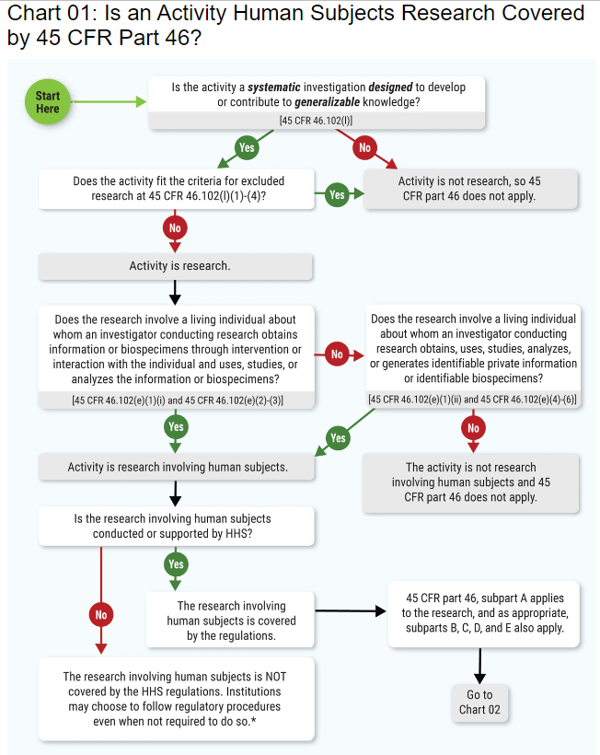

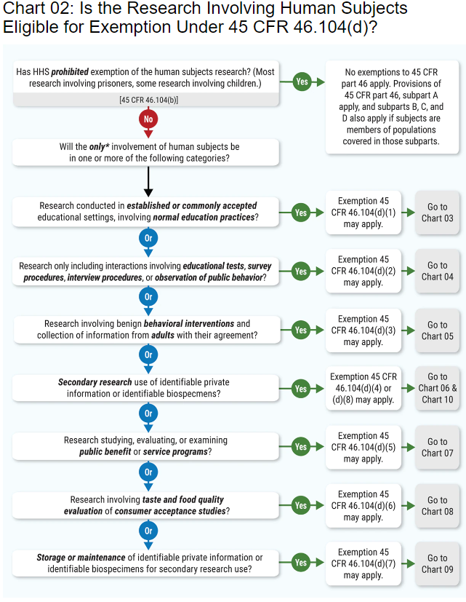

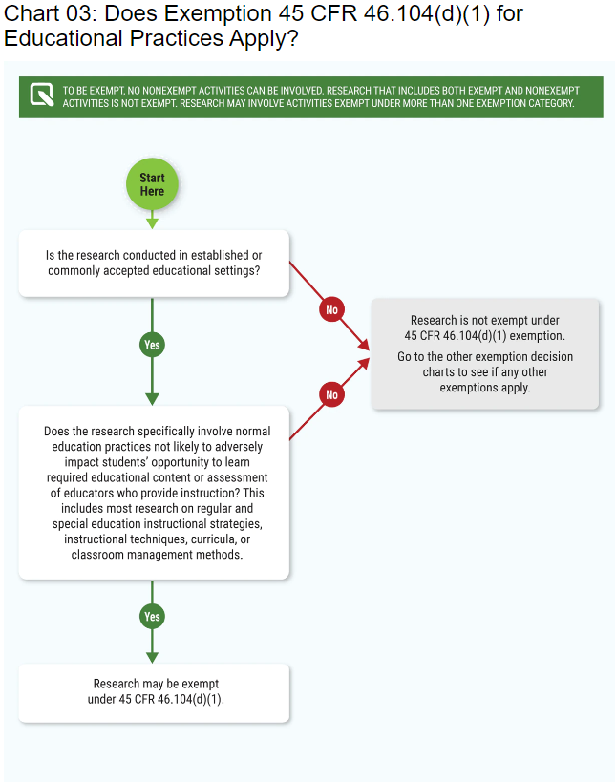

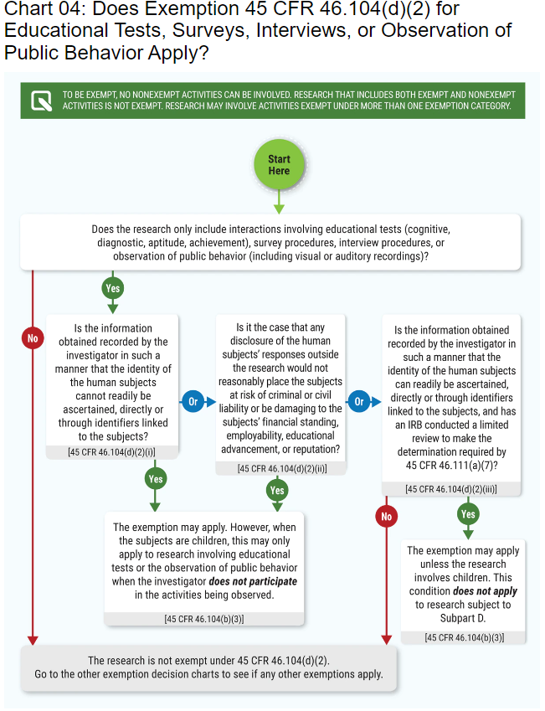

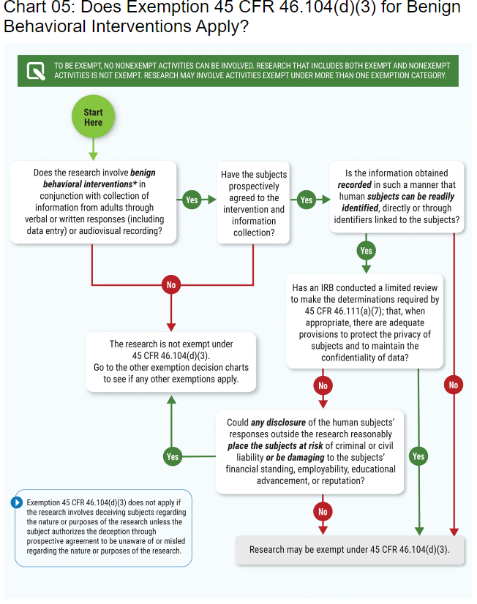

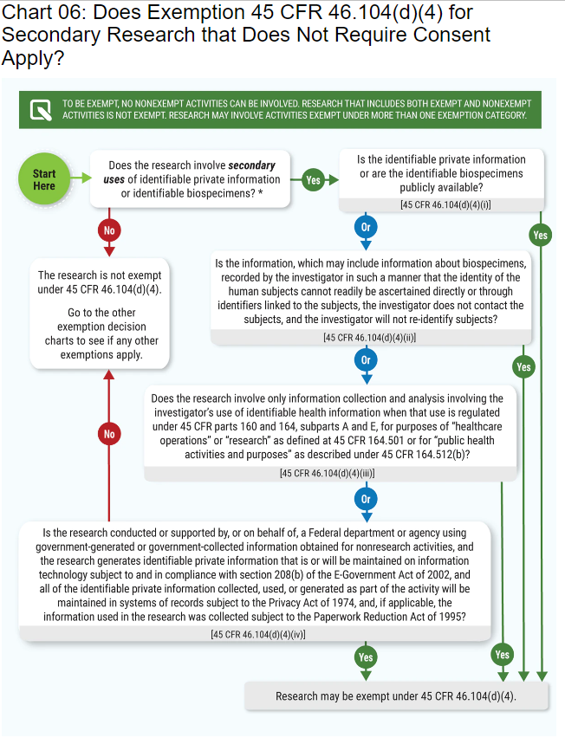

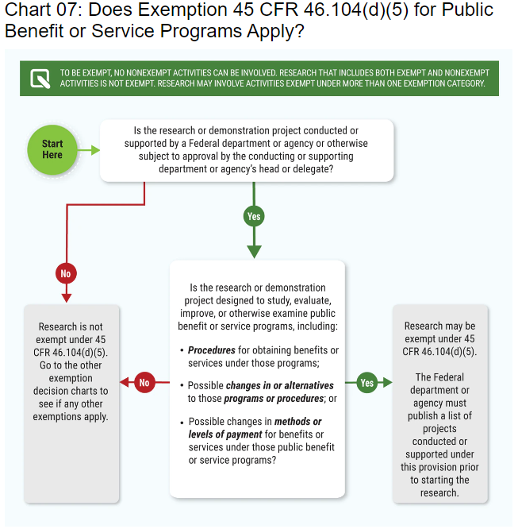

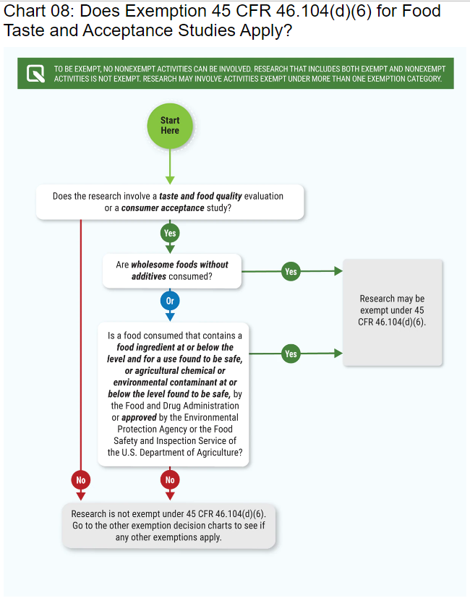

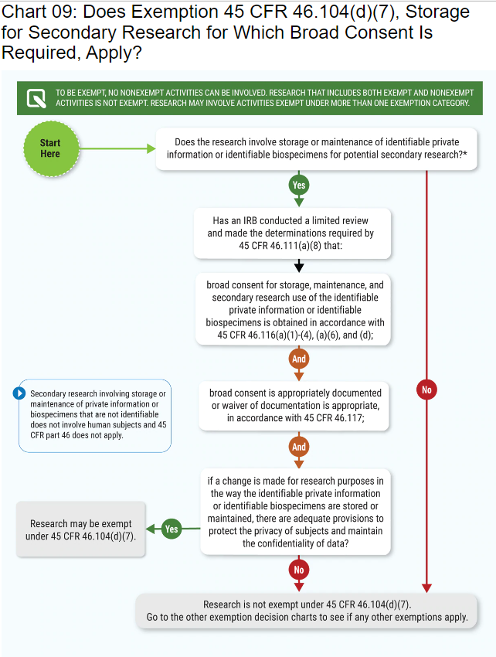

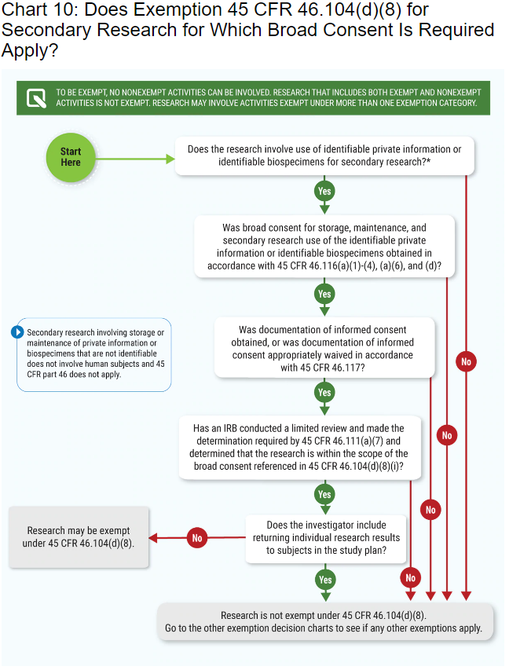

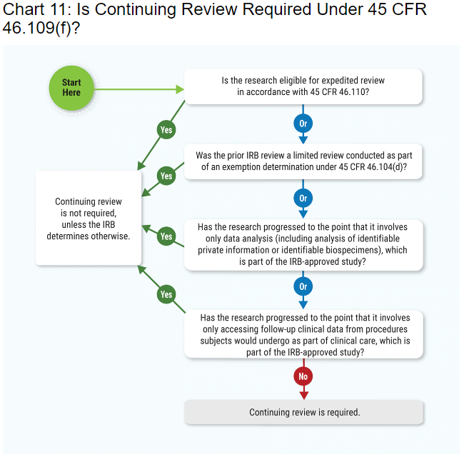

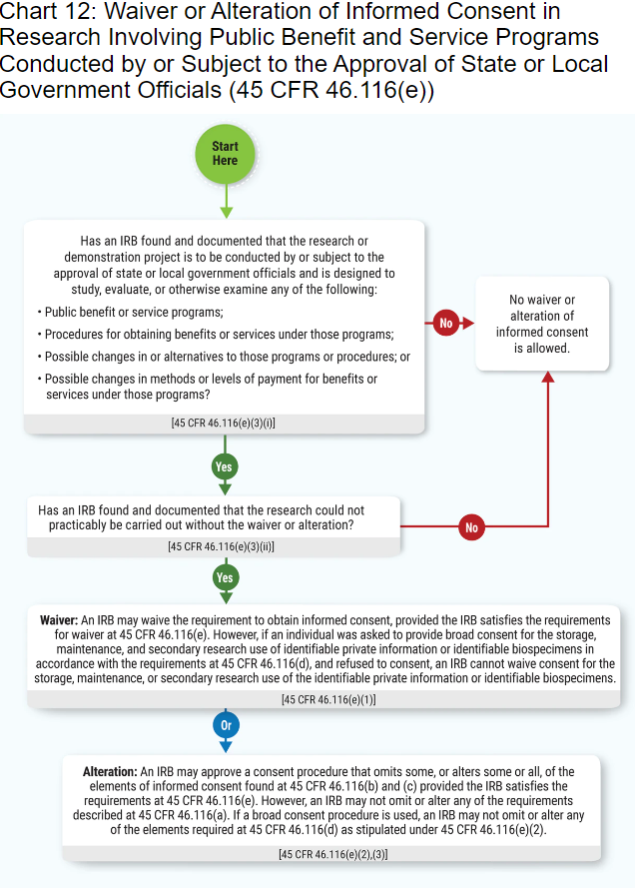

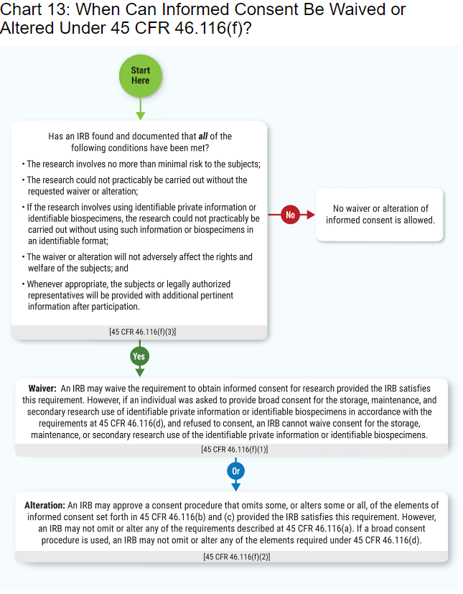

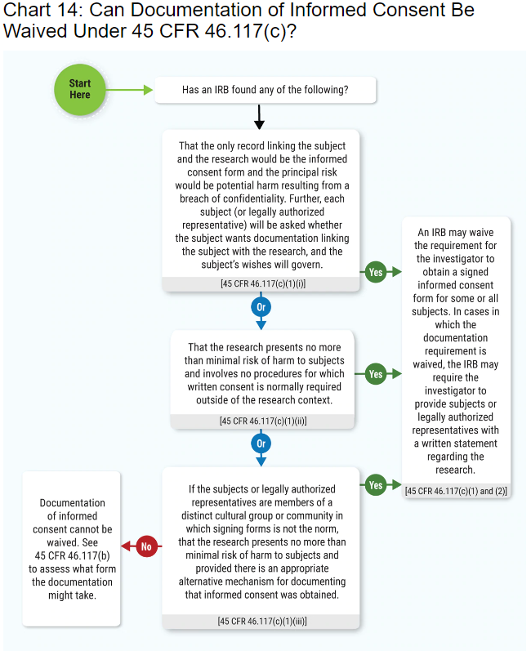

**South Carolina Department of Mental Health**

**Institutional Review Board**

**GUIDELINES FOR AN INFORMED CONSENT FORM TO BE USED IN RESEARCH PROJECTS INVOLVING HUMAN SUBJECTS**

No investigator may involve a human being as a subject in research unless the investigator has obtained the legally effective informed consent of the subject or the subject's legally authorized representative.

An investigator shall seek such consent only under circumstances that provide the prospective subject or the representative sufficient opportunity to consider whether or not to participate and that minimize the possibility of coercion or undue influence.

The information that is given to the subject or the representative shall be in language understandable to the subject or the representative.

No informed consent may include any exculpatory language through which the subject or the representative is made to waive or appear to waive any of the subject's legal rights, or releases or appears to release the investigator, sponsor, the institution, or its agents from liability for negligence.

**ELEMENTS OF AN INFORMED CONSENT**

* + A statement that the study involves research, an explanation of the purposes of the research and the expected duration of the subjects' participation, a description of the procedures to be followed, and identification of any procedures which are experimental.
  + A description of any reasonably foreseeable risks or discomforts to the subject.
  + A description of any benefits to the subject or to others which may reasonably be expected from the research.
  + A disclosure of appropriate alternative procedures or courses of treatment, if any, might be advantageous to the subject.
  + A statement describing the extent, if any, to which confidentiality of records identifying the subject will be maintained and that notes the possibility that the Food and Drug Administration may inspect the records.
  + An explanation of whom to contact for answers to pertinent questions about the research and research subject's rights, and whom to contact in the event of a research-related injury to the subject.
  + A statement that participation is voluntary, that refusal to participate will involve no penalty or loss of benefits to which the subject is otherwise entitled, and that the subject may discontinue participation at any time without penalty or loss of benefits to which the subject is otherwise entitled.
  + For research involving more than minimal risk, an explanation as to whether any compensation and an explanation as to whether any medical treatments are available if injury occurs and, if so, what they consist of, or where further information may be obtained.

When appropriate, one or more of the following elements of information shall also be provided to each subject:

* + A statement that the particular treatment or procedure may involve risks to the subject (or to the embryo or fetus, if the subject is or may become pregnant) which are currently unforeseeable.
  + Anticipated circumstances under which the subject's participation may be terminated by the investigator without regard to the subject's consent.
  + Any additional costs to the subject that may result from participation in the research.
  + The consequences of a subject's decision to withdraw from the research and procedures for orderly termination of participation by the subject.
  + A statement that significant new findings developed during the course of the research that may relate to the subject's willingness to continue participation will be provided to the subject.

**Research and Procedures**

The information provided to subjects should:

* Make clear that the activity involves research and describes the overall experience that will be encountered;
* Explain the procedures, including any parts that are experimental (e.g., a new drug, extra tests, separate research records, or nonstandard means of management, such as flipping a coin for random assignment or other design issues);
* Include the expected length of time it will take for study visits or scheduled procedures, as well as the total expected length of participation.

**Risks**

* All reasonably foreseeable risks, discomforts, inconveniences, and harms that are associated with the research activity, should be described.
* Investigators should be forthcoming about risks and not understate or gloss over reasonably foreseeable risks.
* If additional risks are identified during the course of the research, the consent process and documentation will require revisions to inform subjects as they are re-contacted or newly contacted.

**Benefits**

* Any benefits to subjects or others which may reasonably be expected from the research should be described.
* Investigators should be frank about benefits and not overestimate or magnify the possibility of benefit to the subject. If there is no reasonable expectation of benefit, the subject should be told this.
* Payment to subjects should not be listed or described in the Benefits section.

**Alternatives to Participation**

• Appropriate alternatives to participating in the research project, particularly alternatives that might be advantageous to the subject, should be described. For example, in drug studies, the medication(s) may be available through their family doctor or clinic without the need to volunteer for the research activity.

• Investigators should be reasonably specific about describing the nature and type of available alternatives. It is not sufficient simply to state that "the researcher will discuss alternative treatments" with the subject.

**Confidentiality Protections**

The regulations require that subjects be told the extent to which confidentiality of research records identifying the subject will be held in confidence. For example, sponsors, funding agencies, regulatory agencies, and the IRB may review research records. Some studies may need sophisticated encryption techniques to prevent confidentiality breaches or a Certificate of Confidentiality to protect the investigator from being compelled to release (e.g., under subpoena) subjects' names or identifiable private information.

**Compensation for Injury**

If research-related injury (i.e., physical, psychological, social, financial, or otherwise) is possible in research that is more than minimal risk, an explanation must be given as to whether any compensation and treatment will be provided and if so, what these consist of and where further information may be obtained. **Note that the regulations do not limit injury to "physical injury." This is a common misinterpretation.**

The regulations prohibit

(i) Requiring subjects to waive any of their legal rights, and (ii) leading subjects to believe they are waiving their rights. Consent language regarding compensation for injury must be selected carefully so that subjects are not given the impression that they have no recourse to seek satisfaction beyond the institution's voluntarily chosen limits.

**Contact Persons**

The regulations require the identification of contact persons to answer subjects' questions about the research and their rights as research subjects. Subjects must also be informed as to whom to contact in the event of any research-related injuries.

These areas must be explicitly stated and addressed in the consent process and documentation.

**Contact Persons**

A single contact person is not likely to be appropriate to answer questions in all areas. This is because of real or apparent conflicts of interest. Questions about the research are frequently best answered by the investigator(s). However, questions about the rights of research subjects may best be referred to persons not on the research team. These questions could be addressed to the IRB, an ombudsperson, an ethics committee, or other informed individual or committee.

Each consent document can be expected to have at least two names with local telephone numbers for contacts to answer questions in these specified areas.

**Voluntary Participation**

The regulations require statements regarding voluntary participation and the right to withdraw at any time. Subjects must be informed that:

* Participation is voluntary;
* Subjects may discontinue participation at any time;
* There is no penalty or loss of benefits for refusing to participate or discontinuing participation.

**Additional Protections for Vulnerable Populations**

* The regulations identify three populations as needing additional protections. These are Subpart B Additional DHHS Protections for Pregnant Women, Human Fetuses and Neonates Involved in Research; Subpart C Additional DHHS Protections Pertaining to Biomedical and Behavioral Research Involving Prisoners as Subjects; and Subpart D Additional DHHS Protections for Children Involved in Research. The provisions of these subparts must be met for research to be approved.
* Incompetent adults cannot give consent – this may include the developmentally disabled, the cognitively-impaired elderly, and unconscious or inebriated individuals. Only legally authorized representatives in accordance with state law can give permission for incompetent adults to participate in research.
* In addition to the population described above, when some or all of the subjects are likely to be vulnerable to coercion or undue influence, such as economically or educationally disadvantaged persons or subordinates, additional safeguards shall be included to protect the rights and welfare of the subjects.

**Waiver of Consent**

Under certain circumstances specified in the HHS regulations, the IRB may approve a consent procedure that does not include some or all of the elements of informed consent, or may waive the requirements for obtaining informed consent. To do so, the IRB must find and document that:

* The research involves no more than minimal risk to subjects;
* The waiver will not adversely affect the rights and welfare of subjects;
* The research could not practicably be carried out without the waiver; and
* Whenever appropriate, the subjects will be debriefed – provided with additional pertinent information – after they have participated in the study.
* NOTE – FDA regulations do not provide for a waiver of consent, except in emergency situations.

**The Consent Process**

**Documentation of Consent**

The information that is given to the prospective subject, or his/her representative, must be in language understandable to the subject or representative.

Consent forms should be written at a level appropriate to the understanding of the subjects to be enrolled; technical language should be avoided.

OHRP strongly discourages use of the "first person" in consent documents (e.g., "I have been fully informed about ..."). Such statements unfairly ask subjects to make statements that the subject is not in a position to verify (e.g., the subject has no way to verify that the investigator has provided full and complete information).

Except as allowed below, the informed consent must be documented by the use of a written consent form approved by the IRB and signed by the subject or legally authorized representative. A copy shall be given to the person signing the form.

**Waiver of Documentation of Consent**

The IRB may waive the requirement for written documentation of consent in cases where:

* The principal risks are those associated with a breach of confidentiality concerning the subject's participation in the research; and the consent document is the only record linking the subject with the research; each subject will be asked if they want documentation to remain with them or with the research and the subject's wishes will govern;

OR

* The research presents no more than minimal risk and involves procedures that do not require written consent when performed outside of a research setting.

**Resource Material  
University/College Degree Student Sponsorship Criteria**

The SC Department of Mental Health recognizes and supports the need for student led/conducted research as a vital component of degree programs at universities and colleges. The Department also acknowledges that many students may be unable to financially compensate SCDMH Divisions, Centers, and/ or Facilities for the assistance required by the student to complete required degree completion research. SCDMH offers ten research sponsorships to students conducting research to fulfill degree requirements.  Students must meet the following criteria in order to apply for sponsorships.

1. The student (including student employees) must be enrolled in an accredited College or University program.
2. The research must have clear current and/or potential value to the patients and staff as well as to the student requesting to conduct human subject research.
3. The student must submit a letter to the Director of the Center, facility or Division detailing the estimated time and resources the department may be expected to provide to assist the student in fulfilling their required degree related research project. That letter must be included in the sponsorship application packet.
4. The research must be in-line with the agency mission “To Support the Recovery of Persons with Mental Illnesses.”
5. The research topic must have approval of the student’s thesis and/or dissertation committee.
6. Research must be conducted in accordance with all Federal Regulations that exist to protect the rights and welfare of human subjects involved in research including seeking Institutional review Board when appropriate.
7. Students must complete the IRB/Research approval and application process, complying with SCDMH Institutional Review Board decisions.
8. Students, regardless of financial need, may not conduct any research without the approval of the Facility/Center or division Director, the Deputy Director or Acting Director and, if necessary, the SCDMH Institutional Review Board.
9. Sponsorship packet must include:
   * Project Application for Research
   * Facility/Center Director Letter of Support
   * Estimated Cost Associated with Outside Research form
   * Unaffiliated Investigator Agreement (Non-SCDMH Employee) ***If applicable***
   * Privacy Practices Agreement (HIPAA)
   * Non-Employee Signature Page ***If applicable***
   * Request for a Waiver or an Alteration of Individual Authorization ***If applicable***

**(Note: As SCDMH is responsible for the safety and security of its patients and employees, only the SCDMH has the authority to grant an investigator(s) permission to conduct research on, with or for patients or staff. Although a student may seek research approval from their university or college IRB, no student can substitute that for the approval of the SCDMH IRB.)**

**Informed Consent Resources**

**Additional resources on the informed consent process may be accessed on the HHS Office for Human Research Protections website** [**here.**](https://www.hhs.gov/ohrp/education-and-outreach/online-education/videos/informed-consent/index.html)

**Forms**

**Estima****te Costs/Benefits Worksheets**

**The following form must be completed and submitted as part of the research/grant (circle one or both) approval package.**

**The Estimated costs related to the study/grant: _____________________________________________________ (Study/Grant Title)**

**______________________________________________________ (CMHC/ETR/ Inpatient Facility/Nursing Home name)**

**(By Investigator/Grantee & Organizational Name) ________________________________________________________________**

**Is ___________________________**

**(Rates=Fringex35%, IC 7.92% x total salary & Fringe)**

**Administrative staff time (per person) ____________ Administrative staff time (per person) ____________ Administrative staff time (per person) ____________**

**Clinical staff time ____________ Clinical staff time ____________ Clinical staff time ____________**

**Utilities ____________**

**Office space ____________**

**Computer use/tech support ____________**

**Other equipment use ____________**

**Telephone use/charges ____________**

**Miscellaneous office supplies ____________**

**Miscellaneous ____________ (Explanation: _______________________________________________________________________________________ ____________________________________________________________________________________________________________________________________________________________________________________________________**

**The Estimated benefits related to the study/grant: _____________________________________________________ (Study/Grant Title)_______________________________________________ (CMHC/ETR/ Inpatient Facility/Nursing Home name)**

**(By Investigator/Grantee & Organizational Name) ________________________________________________________________**

**are $__________________________(describe in detail)____________________________________________________ _______________________________________________________________________________________________________________________________________________________________________________________________________________________________________________________________________________________________________________________________________________________________________________________________________________________________________________________________________________________________________________________________________________________________________________________________________________________________________________________________________________________________________________________________________________________________________________________________________________________________________________________________________________________________________________________________________________________________________________________________________________________________________________________________________________________________________________________________________________________________________________________________________________________________________________________________________________________________________________________________________________________________________________________________________________________________________________________________________________________________________________________________________________________________________________________________________________________________________________________________________________________________________________________________________________________________________________________________________________________________________________________________________________________________________________________________________________________________________________________________________________________________________________________________________________________________________________________________________________________________________________________________________________________________________________________________________________________________________________________________________________________________________________________________________________________________________________________________________________________________________________________________________________________________________________________________________________________________________________________________________________________________________________________________________________________________________________________________________________________________________________________________________________________________________________________________________________________________________________________________________________________________**

**Based on the information given I have determined that:**

**____ It is necessary to negotiate a contract between the PI/Grantee and DMH to recoup related costs**

**____It is not necessary to negotiate a contract between the PI/Grantee and DMH to recoup related costs**

**Date: ________________________________________**

**Center/Facility/ Division/ETR Director Signature: _____________________________________________________________**

**SCDMH INSTITUTIONAL REVIEW BOARD**

**Project Applic****ation for Research Involving Human Subjects**

|  |  |
| --- | --- |
| **Title of Research Project:** |  |
| **Principal Investigator:** |  |
| **Job Title:** |  |
| **Business Address:** |  |
| **Telephone Number:** |  |
| **Email Address:** |  |
| **Co-Investigator(s):** |  |
| **Research Intention** | |
| **1. What is the purpose of this study (What research question are you addressing)?** | |
| **2. What is the significance of this project (What will it accomplish)?** | |
| **3. Briefly, outline what you believe to be the clear current and/or potential value to patients and staff of the Department of mental Health and how your research meets the agency's mission.** | |
| **4. Briefly, outline your research design and include a copy of your study protocol.** | |
| **5. Will you be requesting data from the Department of Mental Health (e.g. medical records) and/or the Office of Research Statistics? No**  **Yes**  **If the answer is “yes,” specify the type(s) of data you will be requesting.** | |
| **Research Subjects: Includes all human subject contact and/or chart review** | |
| **6. Who are your subjects (e.g., children, students, patients, volunteers, etc.)?** | |
| **7. How many subjects will be involved?        What is the anticipated starting date of project?        Anticipated date of last contact with research subjects.        How will they be selected?        How will they be recruited?** | |
| **8. What is the anticipated completion date of the research study?** | |
| **9. What is the age of subjects involved ?**  **List any special psychological and physical characteristics with rationale for using any special groups whose ability to give voluntary informed consent      may be in question.**  **Check if there is no concern with consent.** | |
| **10. In non-technical terms what will happen to, and what will be expected of, the research subjects(s)?** | |
| **Confidentiality/Privacy** | |
| **11. In your estimation, do the procedures involve any potential risk for the subject – (physical, psychological, social, or legal) - or invasion of privacy?**  **If yes, what is your assessment of likelihood and seriousness of such risks?** | |
| **12. If methods of research create potential risks, describe other methods, if any, that were considered and why they will not be used).**  **Check here if not applicable.** | |
| **13. What, if any, are the potential benefits to subjects who participate in this research?** | |
| **14. Does consenting to be a subject lead to additional costs in tests, medical care, etc.**  **for the subject? If so, who is responsible for the costs?** | |
| **Subject's Rights Describe your procedures for safeguarding the subject's rights with respect to the following:** | |
| **15. Describe your procedures for safeguarding the subject's rights with respect to the following:** | |
| **16. Security of person (all risks described in No. 13 above)** | |
| **17. Privacy and confidentiality (including protection, storage and retention of data)** | |
| **18. Embarrassment, discomfort and harassment (i.e., would there be any stigma or repercussions from having participated?** | |
| **19. Is there any deception involved in your research? Yes  No  If so, how is it handled?** | |
| **Consent** | |
| **20. Attach a copy of the Informed Consent Form which will be used and describe what your procedures are for obtaining informed consent (include how and where informed consent will be obtained).** | |
| **Research Team** | |
| **21. How will interviewers or data collectors be trained, if applicable?** | |
| **Attachments** | |
| **22. Attach a copy of all test instruments to be used in the study. (Nationally known, common instruments that are likely to be known by the IRB may be listed and not included in the submission.)** | |
| **23. If this project is being conducted to fulfill a college/university degree requirement attach a letter of project approval from your overseeing body, Dissertation Committee, (etc.).** | |
| **24. List all other institutions (hospitals, schools, health care centers, etc.) other than the SCDMH, which will serve as sites for this research project. If these institutions have reviewed and approved this project, attach a copy of their approval form.** | |
| **25. Attach CVs of principal investigator(s).** | |
| **26. If the research requires the use of data/information from patient records attach a letter of project approval from the center or facility director.** | |
| **27. If the research requires the use of data/information from SCDMH Medical Director’s Office-Education, Training and Research Division attach a letter of project approval from the center or facility director.** | |
| **28. Please provide any other information relevant to the study for a full, fair and impartial review by the IRB.** | |
| **29. If the answer to any of the following questions is “yes,” attach a detailed explanation.**   * + **Is there any financial relationship between a commercial sponsor of this project and you or co-investigators? No**  **Yes**   + **Is there any compensation that is affected by the study outcome? No**  **Yes**   + **Do you or your co-investigator(s) have any proprietary interests in any products used in this research, including patents, trademarks, copyrights, and licensing agreements? No**  **Yes** * **Do you or any co-investigators have any equity interest in any company sponsoring this research or any company’s products used or being investigated in this research project? No**  **Yes** | |
| **30. If you are not a DMH employee, you must have a DMH employee, approved by the facility in which the project is being conducted, who has agreed to oversee the conduct of this project and has completed a current. If you are not a DMH employee, please list the following:**   * + - **Name of DMH employee/sponsor:**     - **Employee’s job title:**     - **Employee’s facility and phone number:** | |
| **31.** **All investigators and key personnel submitting IRB applications are required by SCDMH IRB to complete training in human subject protection and submit proof of training.  “Key personnel” include all individuals responsible for the design and conduct of the study.** | |

**I certify that the above and attached information are, to the best of my knowledge, are complete and accurate.**

|  |  |
| --- | --- |
| **Signature:** |  |
| **Title:** |  |
| **Date:** |  |

**Note: Electronic transmission of this document will be considered a valid signature, if originating from the Investigator’s email address.**

**The SCDMH Institutional Review Board meets on the fourth Wednesday of each month at 11:30 a.m. For a project to be considered by the IRB, all relevant materials must be submitted by the first Wednesday of the month. It is preferable that materials are submitted electronically to** [IRB@scdmh.org](mailto:IRB@scdmh.org)**; hard copies can be sent to Lynelle Reavis, Ph.D. Director of Quality Management and Compliance, IRB Administrator at 2414 Bull Street Suite 302, Columbia, SC, 29201.**

**If you need assistance in the completion of this application, please contact Lynelle Reavis, Ph.D. 803 898-8619 or by e-mail at** [IRB@scdmh.org](mailto:IRB@scdmh.org) **.**

**Facility/Cente****r Director Letter of Support-CMHS and LTC**

**(Address letter to the appropriate Deputy Director)**

**_______________________________________**

**South Carolina Department of Mental Health**

**2414 Bull Street**

**Columbia, South Carolina 29201**

**Dear      ,**

**This is a letter of support for the proposed research project/grant (circle one or both), “     ”, to take place at (location)      . I believe the project has potential value to our clients in the area of** **.**

**I am aware of and in agreement that these resources of our Facility/Center will be used to as part of the research project (list out).**

**We look forward to working with       Principal Investigator /Grantee (circle one or both) in pursuing this study.**

**Please do not hesitate to contact me at** **should you have any questions or concerns.**

**Sincerely,**

**__________________________  
Center or Facility Director Date:**

**I approve this proposal to move forward through the DMH research/grant (circle one or both) review process.**

**I do not approve this proposal to move forward through the DMH research review/grant (circle one or both) process.**

**__________________________**

**Deputy Director Date:**

**Facility/Center Director Letter of Support-Inpatient Hospitals**

**(Address letter to the Acting Director)**

**_______________________________________**

**South Carolina Department of Mental Health**

**2414 Bull Street**

**Columbia, South Carolina 29201**

**Dear      ,**

**This is a letter of support for the proposed research project/grant (circle one or both), “     ”, to take place at (location)      . I believe the project has potential value to our clients in the area of      .**

**I am aware of and in agreement that these resources of our Facility/Center will be used to as part of the research project (list out).**

**We look forward to working with       Principal Investigator /Grantee (circle one or both) in pursuing this study.**

**Please do not hesitate to contact me at       should you have any questions or concerns.**

**Sincerely,**

**__________________________  
Facility Director Date:**

**I approve this proposal to move forward through the DMH research/grant (circle one or both) review process.**

**I do not approve this proposal to move forward through the DMH research review/grant (circle one or both) process.**

**__________________________**

**Acting Director Date:**

**Unaffiliated Inve****stigator Agreement and Privacy Practices Agreement for Non-SCDMH Employees**

**All Principal Investigators who are not employees of the South Carolina Department of Mental Health and are seeking approval to conduct research under the authority of the SCDMH Institutional Review Board (IRB) are required to sign an “Unaffiliated Investigator Agreement and Privacy Practices Acknowledgment for Non-SCDMH Employees: Signature Page.”**

**Unaffiliated Investigator Agreement**

**(1) The Investigator has reviewed: 1) *The Belmont Report: Ethical Principles* and Guidelines for the Protection of Human Subjects of Research (or other internationally recognized equivalent; 2) the U.S. Department of Health and Human Services (DHHS) regulations for the protection of human subjects at 45 CFR 46 (or other internationally recognized equivalent; and 3) the relevant SCDMH institutional directives for the protection of human subjects.**

**(2) The Investigator understands and hereby accepts the responsibility to comply with the standards and requirements stipulated in the above documents and to protect the rights and welfare of human subjects involved in research conducted under this Agreement.**

**(3) The Investigator will comply with all other National, State, or local laws or regulations that may provide additional protection for human subjects.**

**(4) The Investigator will abide by all determinations of the IRB designated under the above Assurance and will accept the final authority and decisions of the IRB, including but not limited to directives to terminate participation in designated research activities.**

**(5) The Investigator will complete any educational training required by the Institution and/or the IRB prior to initiating research covered under this Agreement.**

**(6) The Investigator will report promptly to the IRB any proposed changes in the research conducted under this Agreement. The investigator will not initiate changes in the research without prior IRB review and approval, except where necessary to eliminate apparent immediate hazards to subjects.**

**(7) The Investigator will report immediately to the IRB any unanticipated problems involving risks to subjects or others in research covered under this Agreement.**

**(8) The Investigator will obtain, document, and maintain records of informed consent from each subject or the subject’s legally authorized representative as required under DHHS and FDA regulations (or other international or national equivalent) and stipulated by the IRB.**

**(9) The Investigator acknowledges and agrees to cooperate in the IRB’s responsibility for initial and continuing review, record keeping, reporting, and certification. The Investigator will provide all information requested by the IRB in a timely fashion.**

**(10) In conducting research involving FDA-regulated products, the Investigator will comply with all applicable FDA regulations and fulfill all investigator responsibilities (or investigator-sponsor responsibilities, where appropriate), including those described at 21 CFR 312 and 812.**

**(11) The Investigator will not enroll subjects in research under this Agreement prior to its review and approval by the IRB.**

**(12) Emergency medical care may be delivered without IRB review and approval to the extent permitted under applicable Federal regulations and State law. However, data and information obtained as a result of emergency medical care may not be included as part of federally-supported or –conducted research.**

**(13) This Agreement does not preclude the Investigator from taking part in research not covered by the Agreement.**

**(14) The Investigator acknowledges that he/she is primarily responsible for safeguarding the rights and welfare of each research subject, and that the subject’s rights and welfare must take precedence over the goals and requirements of the research.**

**Privacy Practices Agreement**

**The Investigator has reviewed and agrees to comply with the South Carolina Department of Mental Health’s (SCDMH) Privacy Practices Directive, which incorporates the SCDMH Notice of Privacy Practices, and protects the privacy of SCDMH Consumer information and also provides for Consumer rights regarding a Consumer’s control over his or her individually identifiable Protected Health Information (PHI).**

**The Investigator understands that any unauthorized use or disclosure of PHI or violations of any Consumer rights afforded by the Directive, Notice of Privacy Practices and applicable law, may result in applicable fines, penalties, imprisonment and/or civil suit to be brought against me.**

**Please sign the Unaffiliated Investigator Agreement and Privacy Practices Agreement for Non –SCDMH Employees: Signature Page and submit with the completed Project Application.**

**Unaffiliated Investigator Agreement and Privacy Practices Agreement   
for Non-SCDMH Em****ployees: Signa****ture Page \***

**Non-DMH employees must have a DMH employee, approved by the facility in which the project is being conducted, who has agreed to oversee the conduct of this project. Please list the following:**

|  |  |  |  |  |  |  |  |  |
| --- | --- | --- | --- | --- | --- | --- | --- | --- |
| **Name of DMH employee/sponsor:** | | | | |  | | | |
| **Employee’s job title:** | | | | |  | | | |
| **Employee’s facility:** | | | | |  | | | |
| **Employee’s phone number:** | | | | |  | | | |
| **I,** |  | | | | | | | |
| **have read, understand and agree to comply with the South Carolina Department of Mental Health’s (SCDMH) Privacy Practices Directive and Unaffiliated Investigator Agreement and agree to abide by the provisions contained in the document.** | | | | | | | | |
| **Signature:** | | |  | | | | **Date:** |  |
| **Organization:** | | |  | | | | | |
| **Address:** | | |  | | | | | |
| **City:** | |  | | **State/Province:** | |  | **Zip/County:** |  |
| **Phone #:** | |  | | | | | | |
| **FAX:** | |  | | | | | | |
| **Email:** | |  | | | | | | |

**\*To expedite processing of applications, the SCDMH Institutional Review Board will accept this signature page through email submission (along with all other documents being submitted) without an actual signature, if originating from investigator’s email address.**

|  |  |
| --- | --- |
| **Or Mail to:**  **Lynelle Reavis, Ph.D.**  **Director of Quality Management and Compliance, IRB Administrator**  **South Carolina Department of Mental Health**  **2414 Bull Street Suite 302**  **Columbia, SC 29201** | **Email:**  [IRB@scdmh.org](mailto:IRB@scdmh.org)  **FAX: 803.898.8586** |

**SCDMH INSTITUTIONAL REVIEW BOARD**

**CONTINUING REVIE****W OF RESEARCH PROJECT**

|  |  |
| --- | --- |
| **ORA Use Only** | |
| **IRB PROJECT NO.:** |  |
| **Date Received:** |  |

|  |  |
| --- | --- |
| **PROJECT TITLE:** |  |
| **PRINCIPAL INVESTIGATOR:** |  |

The purpose of the continuing review is to ensure that all subjects participating in research projects are protected from research risks as established in procedures approved by the SCDMH Institutional Review Board (IRB) during the initial review. Continuing Review of on-going projects by the IRB is required by federal regulations no less than once per year.

While the questions on this form should serve to organize your response, their primary function is to assist the Board, and you, in certifying that: (1) the project has not deviated in any significant way from the original approved proposal; and (2) no new data has come to light since the last review that would increase the known risks to subjects.

**Please answer the following questions:**

1. How many subjects have been initiated into the research project?
2. What is the minimum number of subjects required in the original proposal to complete this project?
3. Has your project methodology been altered since the original review or last review by the Board in any way that would increase the risks to the subject?   
    Yes  No  (If yes, attach a statement of methodological changes.)
4. Have any research subjects withdrawn from the research project since your last review?   
   Yes  No  (If yes, please attach a statement explaining the circumstances of the withdrawal.)
5. Has any information been learned thus far in your project that would increase the "benefits to research subjects who participate" beyond any benefits outlined in your original proposal?   
   Yes  No  (If yes, attach a statement outlining these benefits.)
6. Have any research subjects experienced any adverse reactions as a result of participation in your study since your last review ?   
   Yes  No  (If yes, please attach a statement detailing the frequency, severity, nature of reaction, possible cause(s) you have considered, proposed or implemented correction and/or your recommendation regarding corrective action.)

7. Based upon the results of your study thus far, has there been, in your opinion, any increase in the risks to subjects beyond any risks specified in your original proposal or since your last review?

Yes  No  (If yes, please attach an explanation of the nature of the risks, any recommendation or plans to reduce these risks and an assessment of the risks/benefit relationship.)

8. Has any new information related to your project come to light since the last Board review which might influence any decision of the Board?   
Yes  No  (If yes, please attach.)

9. Please write a brief statement outlining the current stage of your project.

10. Have any modifications to the Informed Consent been done since Board approval or your last review?  
       Yes  No  (If yes, please attach the revised Informed Consent and highlight the areas where modifications were made.)

11. Please indicate when this project is expected to terminate:

        Date:

12. **If you are not a DMH employee, you must have a DMH employee, approved by the facility in which the project is being conducted, who has agreed to oversee the conduct of this project. If you are not a DMH employee, please list the following:**

* + - **Name of DMH employee/sponsor:**
    - **Employee’s job title:**

**Employee’s facility and phone number:**

I certify that the above and the attached information are, to the best of my knowledge, complete and accurate.

|  |  |
| --- | --- |
| Signature: |  |
| Title: |  |
| Date: |  |

Note: Electronic transmission of this document will be considered a valid signature, if originating from the Investigator’s email address. The SCDMH Institutional Review Board meets on the fourth Wednesday of each month at 11:30 a.m. If you need assistance, please contact Lynelle Reavis, Ph.D. at 803-898-8619 or by e-mail at [IRB@scdmh.org](mailto:IRB@scdmh.org)

**South Carolina Department of Mental Health Institutional Review Board (IRB)**

**REQUEST FOR** **WAIVER OR ALTERATION OF INDIVIDUAL AUTHORIZATION UNDER THE HIPAA PRIVACY RULE**

**Request for Waiver  Partial Waiver  Alteration**

|  |  |
| --- | --- |
| **Title of Research Project:** |  |
| **Principal Investigator:** |  |
| **Telephone Number:** |  |
| **Email Address:** |  |

**1. Provide a brief description of the minimum amount of protected health information for which use or access is necessary.**

**a. Give an estimate of the number of records that will be involved in the project.**

**2. The use or disclosure of protected health information involves no more than a minimal risk to privacy of the individuals based on, at least:**

**a. An adequate plan to protect the identifiers from improper use and disclosure. (Describe the plan)**

**b. An adequate plan to destroy the identifiers at the earliest opportunity consistent with conduct of the research (unless there is a health or research justification for retaining the identifiers)? (Describe the plan)**

**3. Will the alteration or waiver of authorization adversely affect the privacy rights or welfare of the individuals?**

**4. Why can the research not be conducted without waiver or alteration of the authorization?**

**5. Why can the research not be conducted without access to and use of protected health information?**

**6. Are the privacy risks to individuals whose protected health information is to be used or disclosed reasonable in relation to the anticipated benefits if any to the individuals, and the importance of the knowledge that may reasonably be expected to result from the research?**

**Investigator’s Assurance:**

**I assure that the protected health information will not be reused or disclosed to any other person or entity, except as required by law, for authorized oversight of the research project, or for other research for which the use or disclosure of protected health information would be permitted by this subpart.**

**Principal Investigator Signature       Date**

**Note: Electronic transmission of this document to the SCDMH IRB (**[IRB@scdmh.org](mailto:IRB@scdmh.org) **) will be considered a valid signature if originating from the email address of the researcher.**

**Or, the signed form may be mailed to Lynelle Reavis, Ph.D., SCDMH IRB Administrator 2414 Bull Street Suite 302, Columbia, SC 29201.**

**Quick Links**

* Belmont Report: <http://www.hhs.gov/ohrp/humansubjects/guidance/belmont.html>
* FDA Investigational Device Exemptions [http://www.fda.gov/MedicalDevices/DeviceRegulationandGuidance/  
  HowtoMarketYourDevice/  
  InvestigationalDeviceExemptionIDE/default.htm](http://www.fda.gov/MedicalDevices/DeviceRegulationandGuidance/HowtoMarketYourDevice/InvestigationalDeviceExemptionIDE/default.htm)
* FDA Regulations Protecting Human Subjects <http://www.fda.gov/ScienceResearch/SpecialTopics/RunningClinicalTrials/ucm118893.htm>
* Federal Regulations Protecting Human Subjects  
  <http://www.hhs.gov/ohrp/index.html>
* Full List of Exempt Research Categories   
  <https://www.hhs.gov/ohrp/regulations-and-policy/regulations/45-cfr-46/common-rule-subpart-a-46104/index.html>
* Full List of Expedited Research Categories   
  <http://www.hhs.gov/ohrp/policy/expedited98.html>
* NIH Human Subjects Protections Training

<https://humansubjects.nih.gov/resources>

* [​](https://www.palmettohealth.org/document-library/research/informed-consent-template.doc) Federal Policy for the Protection of Human Subjects ('Common Rule')

<https://www.hhs.gov/ohrp/regulations-and-policy/regulations/common-rule/index.html>

* Electronic Code of Federal Regulations Title 45 → Subtitle A → Subchapter A → Part 46

<https://www.ecfr.gov/current/title-45/subtitle-A/subchapter-A/part-46?toc=1>

**For SCDMH Employees:**

* Directive: SCDMH Institutional Review Board-Policies and Procedures for the Protection of Human Subjects <http://scdmhhome/wp-content/uploads/2020/09/896-10.pdf>